

HISTORY

OF THE

LADIES RECREATION CLUB

1883 – 1960

LADIES RECREATION CLUB

------------------------

HISTORY OF THE CLUB

Although this history is not complete, the General Committee has endeavoured to gather all available information, and it is hoped that members may find this publication of interest. It is regretted that little is known of the “twenties” and “thirties”.

The Committee wish to record its thanks and appreciation to Mr. J. Hobbs for his skilful and generous assistance in the preparation of this history.

ROSALIND M. MAYNARD
President

31st December, 1960.
THE BEGINNINGS

It is not known who first had the idea of a Ladies' Recreation Club, although at least two names have survived- those of Mrs. Jackson and Mrs. March. In a letter from Mrs. Kathleen M. Tabor we are told: "I was in Hong Kong as a child at the time of the opening of the Club, and my mother, the late Lady Jackson, wife of the Chief Manager of the Hong Kong and Shanghai Bank, was one of the promotors". Mrs. March is mentioned in the following extract from the "China Mail", which also establishes for us the exact birthday of the Club - February 1st, 1884:

"This afternoon the Ladies' Recreation Club of Hong Kong was formally opened by Lady Bowen in the presence of a number of ladies and gentlemen. The idea of a Ladies' Recreation Club was mooted some months ago, and met with such approval among the ladies that a number of them at once took steps to try and realize the idea. This they have very successfully accomplished, and the ladies of Hong Kong are now in possession of a resort where they can obtain physical recreation of the most health-giving and bracing kind. Four spacious lawn tennis courts, each one forming a terrace, have been constructed at no inconsiderable trouble and expense on a pretty site on the face of the hill, quite close to the road to the Peak, and very easy of access. Here the ladies will be able to enjoy in quiet and without interruptions the pleasures of the Queen of Ladies' outdoor games. The floors of two of the courts are of chunas and the other two are the ordinary grass courts. The latter will be greatly improved after the rains. A nice flight of broad steps runs down the side of the courts, which are all enclosed by netting. Perhaps, when the funds of the Club permit, a pavilion will be built on the spot, but in the meantime there is no shelter of any kind erected.

This afternoon, a small marquee was put up on the upper-most court, and from this refreshments were supplied. Among the ladies present was Mrs. March who has been a most

- 2 –
prominent and energetic promoter of the scheme, and the Misses Bowen, while among the gentlemen we noticed His Excellency Major-General Sargent, Sir G. Phillips, and Admiral Goltz. Lady Bowen having opened the Club by delivering a few balls in one of the courts, a number of parties were arranged, and though the weather was raw and cold, play was carried on vigorously during the afternoon. The Band of the Buffs, under Bandmaster Quin, enlivened the proceedings by performing a very pleasant selection of music".

Several things are clear from this excellent report. One is that gentlemen were associated with the Club from the very beginning. Among other tasks, they could obviously serve as trustees, for not until .1938 was the Club incorporated, and thus trustees were needed, presumably mainly to guarantee the financial state of the Club. When the Secretary wrote to the Surveyor, P. W.D., on June 29th 1883, she submitted the names of Messrs. Thomas Jackson, C.D. Bottomley and F.D,.. Sassoon as proposed trustees. These were accepted, and at the end of that year, the first Crown Lease was issued to them for I.L. 898. It was for 75 years, at a Crown Rent of $1 per anl1um. In 1890, this lease was surrendered, apparently because of minor alterations to the boundaries of the lot, and a new lease for a slightly different site was issued to the trustees of that time, who are recorded as being James Johnstone Keswick, William Howell Forbes, and George Edward Noble.

It is also clear from the report of the formal opening that tennis was to be the Club's main sport, although other sporting activities took place there at various times, as we shall see later.

THE NEW CLUB

We can imagine those first 4 courts, in terraces much as they are now, and with the same "nice flight of broad steps". Also, plans were in mind to build the first "pavilion" or Club house. The present old clubhouse, now used for junior members, was opened in 1915, but there was a building on

- 3 -
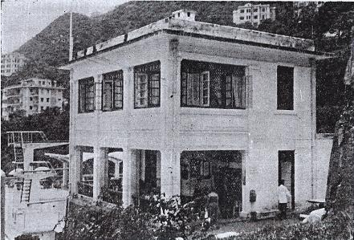

The Original Club House, later known as “The Junior” Club House, opened in 1915.

- 4 -

the site before that, for Mrs. K. M. Tabor mentions in her letter "a very pretty little Club House where tea was provided." The same letter says that the site was chosen for the convenience of those who lived on the Peak, and that husbands on their way home from work (by sedan chair in those days before the Peak Tram) could join their wives for tea and tennis.

The teas at these tennis afternoons were of such excellence that they have been remembered much more by past members of those years than dates and personalities. "Of that period, what remains clearest in my mind were the free teas, with large homemade cakes supplied in turn by the Committee" is a typical reminiscence.

However, tennis was also taken seriously. There was even an Interport match before 1886, when Singapore sent up a team to compete in singles and doubles, which was a great success. Many tournaments and matches were arranged which were well patronized. So keen were some members that they urged that play on Sunday afternoons should be allowed - a bold suggestion in those days. There was "a terrific uproar at the Committee meeting, it was strongly disapproved", remembers one, while another speaks of "a lost battle in which those in favour of the status quo (no Sunday tennis) had been urged on by the Chaplain of the Cathedral, the Rev. H. Copley-Moyle".

No records remain of the championships, although Mr. H.J. Armstrong has said, "I can remember proudly watching my mother win the Ladies' Singles Tennis Championship and collect a large cup". This would have been about 1909-10. We must admire those ladies for playing at all, when we think of the cool and light modern outfit compared with what was then worn. One description records, "The L.R.C. had colours, broad red and white stripes, and I remember that I and my sisters wore hat bands around our straw 'sailor' hats, as they were called in those days, and ties on our high- collared shirt blouses that we wore with long, white skirts- almost down to the ground".

- 5 -
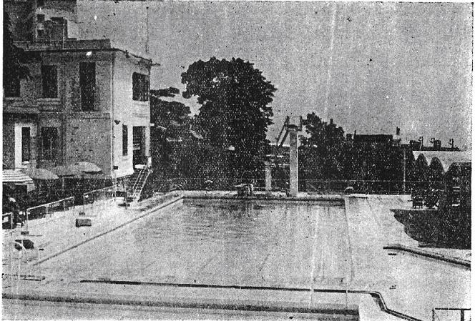

The main swimming pool showing The Junior Club House, opened on 30th April 1949

- 6 -
THE LADIES RIFLE ASSOCIATION

Another "terrific uproar" of those days, though paradoxically of a more friendly nature, must have been caused by the Ladies' Rifle Association. The range was below the tennis courts, near the filter beds, and so near the present courts 7, 8 & 9. In 1895 application was made to use the site as a rifle range. A certain Madame O'Gorman started this particular activity; she was the wife of Colonel M. O'Gorman, who held a staff position in the Garrison. Mrs. Prophet made an attempt in 1955 to get further information about them, but eventually the War Office reported that both had died. Madame Q'Gorman seems to have been a colourful character, and it is a pity that there are no details of what she was like

Apparently, as with tennis, the shooting was enthusiastically supported, and monthly shoots were held as well as a yearly meeting. Past members still have spoons, with the initials "L.R.A." on the handles, which were prizes won in the monthly competitions.

CROQUET

Quite early on in the history of the Club, croquet became a popular game. Mr. H. J. Armstrong, in the speech he made on the occasion of the laying of the foundation stone of the new clubhouse in April 1955, mentions it:

"Court 3, the site of this clubhouse, was then a grass court big enough for croquet on which overdressed gentlemen in tight trousers and waistcoats, equally overdressed ladies in trailing skirts and large hats, battled their way through the hoops." His mother, besides her prowess at tennis, was also Croquet Champion in 1910.

Another old member, thinking back, mistakenly thought that the club was originally for croquet, although from the China Mail report of the opening, it is clear that tennis was the club's first purpose. However, it does show how important croquet must have been at one time.

- 7 -
Mention is also made by another past member of the many devotees of the game, but "for some reason unexplained, it was only ephemeral." A former member, Mr. P. Cassidy, mentions that "Mr. Paul Hodgson, in his straw boater, was the unexpected Croquet Champion for many years." We can only presume that members became tired of trying to beat the unconquerable Paul Hodgson, so that the game waned.

CRICKET

Yet another game which the ladies of those early years took an interest in was cricket. However, we must not imagine that the ladies themselves bowled and batted in the voluminous skirts and large hats of the 80's and 90's. Instead, they chose gentlemen to represent them against the H.K.C.C.

The first match was on October 31st and November 1st 1884 at Chater Road, and the representatives of the ladies went first to the wicket. Mr. E.J. Coxain was the hero of the first innings with 54, which was nearly half the score. However, the L.R.C. did not do so well in the second innings, and eventually the H.K.C.C. won the match.

There was another cricket match against the H.K.C.C. some years later, on March 12th. 1904. We are indebted to Mr. Arthur Rumjahn for the full scores of this game:

H.K.C.C.
Lord Hawke, b. R. Hancock
T. (Tam) E. Pearce, b. R. Hancock
C. H. MacKay, c. H. Hancock, b. Lumsden
Major Williamson, c. H. Hancock, b. Lumsden
Capt. Davies, c. Aitken, b. Lumsden.
Eng. Lt. de Paris, b. Rutherford
M. C. Bonsor, b. Lewis
J. T. Dixon, b. Lumsden
W. Daniels, c. R. Hancock, b. Heath
G. E. Monell, b. Lumsden
R. E. O. Bird, not out . . . . . . . . . . . . . . . . . . . . . . . . . . .
Extras
Total. . .
- 8 -
BOWLING ANALYSIS

Lumsden...
R. Hancock.
Phelips ."'.
Lewis . Rutherford. .
Heath. . . . . .
Turner .

L.R.C.
W. C. Q. Turner, b. J. T. Dixon
Major lewis, c. Davies, b. Monell
Lt. Heath, b. J. T. Dixon
R. Hancock (Capt.), b. J. T. Dixon
Lt. lumsden, c. Bonsor, b. Monell
Harry Hancock, c. Pearce, b. Monell
Com. Bentwit, c. Dixon, b. R. E. O. Bird
Col. Aitken, c. de Paris, b. Monell
H. R. Phelips, c. Dixon, b. MacKay.
Lt. Butt, not out
N. H. Rutherford, l.b.w. MacKay
Extras

Total

BOWLING ANALYSIS

J.T.Dixon 23 4
R.E.O.Bird 15 2
Monell 13 1
MacKay 5 0

This match was of more than ordinary interest through the participation of Lord Hawke, who was Captain of Yorkshire and an England selector. The H.K.C.C. did well to play him as an Honorary Visiting member, and would have liked him to play for them again, but he had to leave the Colony "to be in time to sit on the Committee of Selectors for the England XI to battle with Australia in the coming

- 9 -
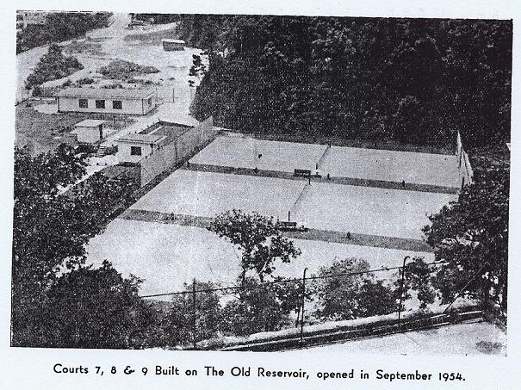

- 10 -

Test." However, the outstanding performance seems to have been by Harry Hancock, with his 93 runs. The L.R.C. team did very well to lose by such a small margin.

What other matches there may have been have not as yet come to light? Will gentlemen ever again represent the ladies of the L.R.C.?

The early years were very busy ones indeed for the L.R.C. and it is interesting to get a further glimpse of what things were like from the impressions of Rudyard Kipling. He visited Hongkong, and in "From Sea to Sea and Other Sketches", written 1887-9, has the following:

"Once, before I got away, I climbed to the civil station
of Hongkong which overlooks the town. There in sumptuous stone villas built on the edge of the cliff and facing shaded roads, in a wilderness of beautiful flowers and a hushed calm unvexed even by the roar of the traffic below, the residents do their best to imitate the life of an Indian up-country station. They are better off than we are. At the bandstand the ladies dress all in one piece - shoes, gloves and umbrellas come out from England with the dress, and every memsahib knows what that means - but the mechanism of their lives is much the same. In one point they are superior. The ladies have a club of their very own to which, I believe, men are only allowed to come on sufferance. At a dance there are about 20 men to one lady, and there are practically no spinsters in the island. The inhabitants complain of being cooped in and shut up. They look at the sea below them and long to get away."
Has Hongkong changed so very much? At any rate, seventy years later there is still the roar of traffic - and the L.R.C.

The mention of the bandstand reminds me that the L.R.C. was also a musical place on Sundays. Mrs. Gladys White remembers that “They used to have bands from various

- 11 -

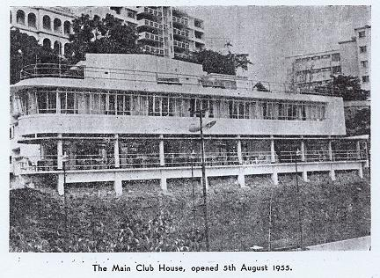

- 12 -
Warships to play in the gardens of the club on Sundays. On one occasion prior to the 1914 war it was the band of a German cruiser.”

THE TWENTIES

At present, we know little about the Club in the twenties. Perhaps the music from the bands of various warships gave way to the Charleston and the Black Bottom. As one past member remarks in a letter, "Those old Minute Books that were lost in the war were full of entertaining items." However, a club report of 1924 does not sound exciting or carefree. At that time, the club was in such a bad state of repair that Mrs. M..I. Hancock approached Government for a loan. of $4,500 for repairs. The Club was mortgaged to repay the 'loan in 5 years at 50% interest. These repairs were, of course, to what is now the Junior Clubhouse.

THE THIRTIES

From the scanty reports and the statements o£ account which are available for the pre-war years, it seems that the Club was continuing steadily, without making any spectacular progress. Upkeep and repairs took most of the profits, although in 1936 alterations were made in the Club premises, which included modern sanitation and showers.

Membership was fairly steady at above the 300 mark, declining a little from 347 members in 1934 to 308 in 1936. The sums of money involved seem ridiculously small to us today. Annual subscriptions were about $10 and entrance fees about the same, depending on the type of membership. In 1934 staff wages, including ball boys were about $1700, and in 1936 were still under $2000 per annum.

In 1938 the Club was at last incorporated under the Companies Ordinance (1933), having from 1883 been unincorporated. Permission was thus given to assign the Club to L.R.C. (Inc.) from the trustees, who were D.H. Blake, H. Owen-Hughes and Mrs. M.I. Hancock. One result of this was that the liability of members was limited to $100.
.
- 13 -
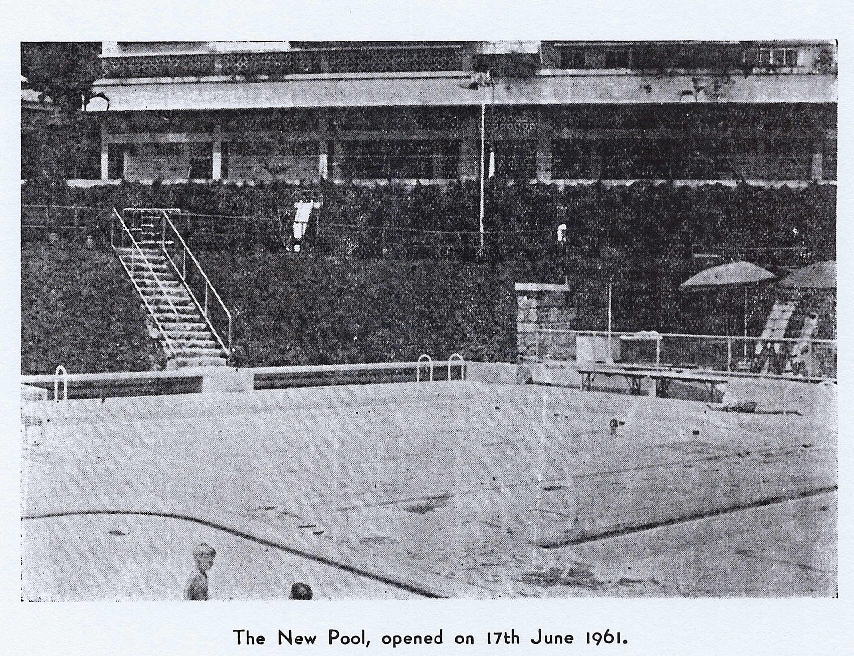

- 14 -

Considerable progress was made in this decade in improving the facilities for tennis. As Mr. H.J. Armstrong remembered: "Then (during the 30's) suddenly the L.R.C. from being a rather Edwardian Tennis Club realised that to survive it must progress. An enterprising committee dug up one of the concrete courts and laid a modern brick dust court, the first in the Colony, which was a great success. Others followed, and when the war came only 2 of the concrete courts and none of the grass courts remained."

THE AFTERMATH OF WAR

When the war finished, it was a scene of desolation which met members on their return. The Club then has been described as "a car park and a slag heap." Apparently the Japanese had begun to alter the shape of the grounds in preparation for the erection of a shrine.

Tremendous problems had to be faced to get the Club on its feet again. The Club today, with all its amenities and comforts, virtually did not exist in 1945. Its reconstruction was carried through by the hard work and enthusiasm of the Committees, as well as of members and friends of the Club, including many commercial firms. A short year to year review of progress from 1945 to 1960 will give an idea of how much has been accomplished, and will show that during no previous period had the Club expanded so much and prospered so well.

RECONSTRUCTION - FIRST STEPS

In April 1946, the Club officially passed into the hands of Mr. S. Jarvis, of the Hongkong Electric Co. and Mr. J.F. Marshall of the Hongkong and Shanghai Bank. Then on December 30th an Extraordinary General Meeting was held in the S.C.M.P. Board Room to set up the Club organisation once more and to begin to tackle the problems of reconstruction. Mrs. Digby was elected President, and she and her Committee were authorised to borrow funds from the H.K.

- 15 -
and Shanghai Bank to restore the courts and clubhouse to 1941 standards. It was estimated that $50,000 would be needed. Obviously money was more important than ever, and entrance fees were raised to $50 and $75 for single and double memberships, and half yearly subscriptions were also increased to $40 and $50.

By the end of the next year, 1947, much had been done, 5 red brick and 1 concrete courts had been rehabilitated, tournaments were played, membership was up to pre-war level at 322 members, and a Junior section was started. Further improvements were planned, for among other things more courts were needed, and so the Committee invited Mr. R.W.A. Mackichan to survey and plan further development of the Club grounds with a view to including additional amenities. The major scheme to emerge from this was, of course, the building of the swimming-pool.

1948

More money was needed, and in April of this year, half yearly subscriptions were increased to $45 and $75 for single and double membership respectively, although entrance fees remained the same. Mrs. Digby was still President until she went on leave at the end of the year, when Mrs. I. W. Shewan took over.

By the end of the year, further progress had been made. Membership had increased to 448, Club Championships were included in the Annual Tennis Tournaments and League Matches were played, for by now 8 courts were completed. Social evenings were started and there were "keep fit" classes. Work on the swimming-pool was already in hand. An important decision was made to spend no more on the Clubhouse, as it was considered a new one would be necessary to meet the Club's expansion.

1949

Mrs. D. L. Prophet now began her "reign" which indeed turned out to be a nine years' wonder; A drive was begun

- 16 -

to reduce the large overdraft with the bank, and there were many novel schemes to raise money.

Membership was up to 612, with a Junior section of about 500. Entrance fees were raised to $150 and $225 for single and double membership, so that newcomers would share in payin{!; for the capital expenditure which had previously been borne by those who had joined the Club in earlier stages.

The event of the year, however, was the opening of the swimming-pool by Mrs. Prophet on April 30th.

Building the pool had been a splendid achievement.
There had appeared to be no available space; there were certainly insufficient funds; and membership was far less than it is today.

The opening had been arranged for a Saturday afternoon and as so often happens, Hong Kong had had a glorious week of sunshine but on that day there was a tropical storm. The Committee were undecided whether or not to postpone the event, but as all arrangements had been made and members were naturally anxious to use the pool, it was decided to go ahead. Members and guests were huddled on the present Junior Club House verandah, and the rain continued in torrents.

Mrs. Prophet stood under the diving board complete with speech, and with somebody holding a huge umbrella over her. A microphone and loud speakers had been hired for the occasion, but at the last moment they refused to function. In spite of all this, Mrs. Prophet carried on regardless, although hardly anybody heard a word.

Afterwards, an exhibition of diving and swimming was given by a number of teen-agers. This was followed by tea and cakes for all the rather damp onlookers on the verandah. Thus, the weather was overcome, as all the previous difficulties had been.

- 17 -

1950 - 1952

Following the opening of the pool, a Filtration Plant was installed in 1950 and the project was complete. Partly as a result of this great attraction, many more people applied to join, and during this period membership increased to well over 700, so that for a time the Club could accept newcomers only to replace those who had resigned.

Honorary membership was offered to the Governor and Lady Grantham and to other leading Colony representatives. In fact, the Club had reached the end of what might be called "stage one" of reconstruction, and was once again flourishing and popular.

MONEY PROBLEMS AND THE NEW CLUB HOUSE

The drive to reduce the overdraft continued, and its success may be gauged by the reduction of over $31,000 made in 1951, and of over $37,000 in 1952. In the latter year, rising costs and the hope of ever greater development, increased subscriptions again, and there was also a levy.

The new clubhouse, so urgently needed, was in every- one's mind, but the financial problems seemed insuperable. The overdraft was still large, and it was undesirable, to say the least, to start such an ambitious project while still so much in debt. Thus it needed courage and foresight, plus a lot of hard work looking into 1,001 details of leases, and legal and financial points to get any further. These qualities, and a willingness to devote time to the problems were forthcoming under the leadership of Mrs. Prophet. Gentlemen have happily always come forward to help the ladies throughout the history of the L.R.C. and they did so now, notably Mr. 'Pouf' Prophet, whose contacts and experience were invaluable.

At the end of 1951, the figres looked formidable. The
overdraft was approximately $150,000, and it was estimated that $200,000 would be required for the new Clubhouse,

- 18 -
which meant $350,000 had to be found. The outlook was indeed discouraging, and it would have been understandable if plans had been shelved for an indefinite period.

However, the Committee went ahead, and a Debenture Scheme was devised in 1952. Debentures were to be issued in multiples of $250, with 3% interest payable half-yearly, and members and commercial firms were invited to contribute. At the, same time a Building Committee was set up to discuss the plans, so that work could start immediately funds were available.

Meanwhile the overdraft was rapidly being reduced, and the figures make impressive reading. On December 31st 1952, the overdraft with the H,K. and Shanghai Bank was $115,405. By the end of September 1953, it had been cut down to about $60,000, while the Debenture scheme had risen to over $46,000, and the scheme was extended for another year.

Then came very good news. In spite of having been very cautious at first about the Club's chances of success in raising such sums, the Hongkong and Shanghai Bank now promised a loan of $100,000 to the building fund if the overdraft could be liquidated before December 31st 1954. A final successful effort was made to do this. In addition, the Debenture Scheme had risen to $99,335 by the end of 1954.

These figures, which some people may think uninteresting, in fact represent a great effort, and also show the healthy state and adventurous spirit of the Club. As an illustration, we quote a part of an interview on Radio Hongkong which Mrs. Prophet gave just prior to the opening of the new building.. In mentioning the individual enterprise of members in raising funds, she said, "one member brought a weekly supply of vegetables and flowers from her garden to sell. Two others gave a cocktail party and charged an entry fee. (That project alone raised $2,000). Two other members

- 19 -
ran a dinner party on the same lines, others organised Bridge Drives, Beetle Drives, Progressive Games Evening, Jumble Sales and many other forms of entertainment. It was the driving force and determination of these members which inspired us all to co-operate to get the Club on its feet, The Committee drew up a rough plan of all the future possibilities of the Club, so that everyone knew what he was aiming for ultimately; and by the end of January this year (1955) we actually boasted a credit balance in the bank, the first time since the beginning of 1947."

Construction work actually took only five months, showing, the wisdom of all the advance planning that had gone on. When Mrs. Prophet laid the foundation stone on April 14th 1955, the new building was already taking shape behind a framework of wooden scaffolding. On August 5th Lady Grantham performed the opening ceremony.

The excessive rains of 1957 caused a landslide below the far end of the pool, which naturally dismayed the Committee and their Financial Advisers. However the damage was made good by the construction of a retaining wall, and in addition, the Club's own piece of reclamation took place, providing space for a children's playground.

The turfed area at the end of the pool, which became a quagmire in the rains, was tiled.

In March, 1959, Mrs. Prophet resigned from the post of President, but although she and Mr. Prophet left the Colony, they still remain members of the L.R.C. as, to mark their long association with the Club, they were made the first Life Members.

Mrs. R. W. H. Maynard took over leadership of the Club in March 1959, and progress continued, especially in the work of increasing amenities. First, plans for improving the tennis courts were put into action.

- 20 -

As courts 4 and 5 were constantly unfit for play owing to heavy rains during the summer, and as great difficulty was experienced in watering them during the dry season, the Committee decided to resurface both these courts with green "no upkeep" En Tous Cas. This has enabled far more use to be made of these courts, as they dry very quickly after rain, and do not heed watering in the dry season.

So popular was this new surface, and such were its advantages that it was decided to have it laid on the lower courts Nos. 7, 8 and 9. This work should be completed by the beginning of 1961. Earlier, the approach to these courts had already been improved, for during 1960 the broad flight of steps to them from May Road was entirely rebuilt.

Perhaps the greatest improvement was the provision of flood-lighting, to make evening tennis possible. The highlight, in more ways than one, of the 1959 tennis season was the opening of the floodlit courts Nos. 4 and 5, by the President, Mrs. Maynard. This took place in a brief but impressive ceremony on the courts, and was made possible by the generosity of a member and a Colony Hong in donating their debentures to the Club.

By 1960, overcrowding in the Swimming pool had become a pressing problem, and plans were prepared for the construction of a separate pool, 36 feet by 30 feet, for coaching and. non-swimmers, to relieve the strain on the main pool. Work began during December 1960, and the project should be completed by the beginning of the 1961 swimming season.

The Club today is among the best in the Colony and offers a great variety of amenities. Finances are good and the present membership is 867 active, 131 absent members, and 554 junior members. One of the Committee's biggest problems is trying to cope with the continuing demand of newly arrived residents who wish to join the Club.

- 21 -

The next item on the agenda for improvement is the proposed demolition of the present Junior Club House and the construction of a Family Club House. Design drawings have been made and it is hoped that work will commence during the, Autumn of 1961.

Various other improvements and additions are under consideration and members may rest assured that the progressive spirit of the Club, especially evident since the war, will be continued.

- 22 -

